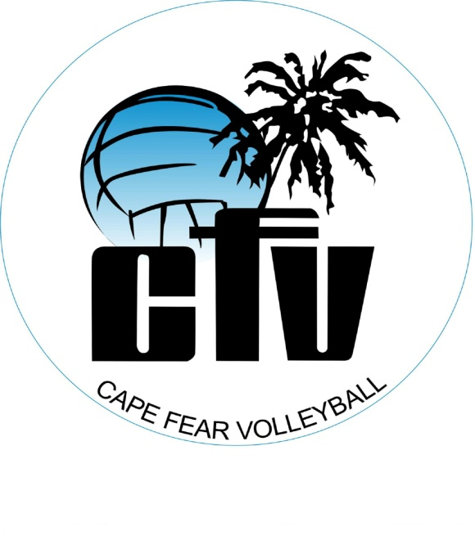
Cape Fear Volleyball Vollapalooza Fundraising Registration Form
Friday Nov. 15th 7:00 P.M. – Saturday Nov.16th 10:00 A.M.
Location: The Hanger (1501 John Morris Rd 28405)
Name of Player:
Age:
Email:
Phone:
T-shirt size: S M L XL
Parent/Guardian:
Email:
Phone:
- I pledge to register for Vollapalooza at the cost of $20. If my pledges meet or exceed this amount, my registration fee will be waived. Please initial here:_______
- I have registered with the Carolina Region Volleyball. http://www.carolinaregionvb.org/ Please initial here:______
- I commit to being locked in the CFV hanger from 7:30PM Nov. 15-10:A.M Nov 16th. - Please initial here:_______ (DevPro is excluded – DP 7:30 – 11:00 PM)
Parent Signature:
Player Signature:
Let’s have fun, make memories and raise money for our club! Money raised will go toward tournament fees and rent for our facility.
Thank you for allowing your child to participate!!!!! Please return this form to Maggi Apel. All payments will be due at check in on Nov. 15th apel42@msn.com

