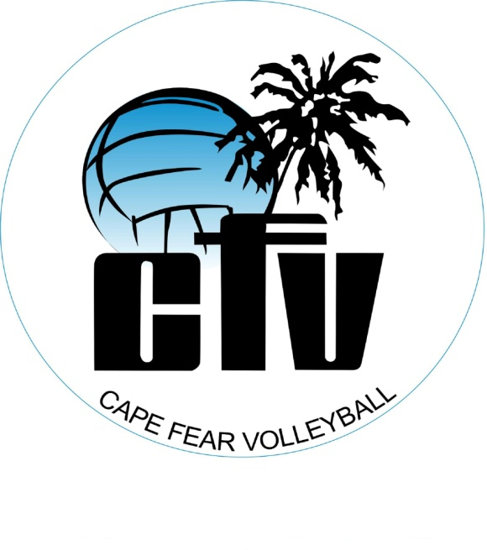
Cape Fear Volleyball Fundraiser November 15-16th 7:30PM-10:00AM Location: The Hanger
We would like to introduce Vollapalooza! This fundraiser is a 2 day celebration of a volleyball lifestyle and will consist of 14 hours of nonstop volleyball play. Our goals are to raise money and awareness for Cape Fear Volleyball as well as building tradition and lasting memories for our teams.
The primary need of this fundraiser is for the increased costs of moving into the hanger. In order to pay for the hanger with dues alone, we probably need to increase fees by at least 40%, which would be a true hardship on many players. These funds should also allow for scholarship/partial scholarships for some players.
How does fundraising work?
- We must recruit players! We are asking all players interested in playing with the CFV club’s 2013-2014 season to participate. All levels and ages are encouraged and welcomed!
- Each player will ask for $ pledges from family members, friends, neighbors etc, for every hour they think they will play. There is a total of 14 hours of available play! Example: Sally’s grandmother pledged $20 for each hour of play. Sally played 4 hours of volleyball, so the Grandmother gives Sally $80. Or, Sally’s neighbor pledged $1 for every hour of play. Sally played 12 hours, so Sally’s neighbor gives her $12.
- We also have a website you can visit to make a onetime donation in the name of a particular player. www.youcaring.com
- Any money collected before the event can be turned in at check in. Pledges that come in after the event will be turned in no later than 1 week after Vallapolooza. Someone will be at CFV practices the following week to collect the pledge money.
How are teams selected?
- Check in will begin at 7:30 P.M November 15. A drawing of all girls registered will begin at 8:00 P.M. Two girl’s names will be drawn from each age group (13-18) and the teams will consist of mixed ages. Play will begin at 8:30 P.M. and will end at 10:00 A.M. November 16.
- DevPro teams (ages 7-12) will check in at 7:00. A drawing of all girls registered will begin at 7:30 P.M. and play will be open from 8:00 P.M.-11:00 P.M. This gives the girls 3 hours of fun and could be a good opportunity to introduce the club to new girls. There will be no overnight stay for the DevPro girls.
Who is eligible to participate?
- Girls from 7-18 who are interested in playing for CFV 2013-2014 season. They must be currently registered with Carolina Region Volleyball. Every girl that intends to play club volleyball with CFV will need to register anyway. Let’s all be current before the season kicks off. http://www.carolinaregionvb.org/
- Please see attached form to register for Vollapalooza. The cost per player is $20, unless your total number of pledges are more than $20, then the $20 registration fee would be waived!
Who will be watching our children?
- We intend to have coaches and parents as chaperones. This will be a locked in event and no player will be able to leave until the end of Vollapalooza at 10:00 A.M. on Saturday November 16.
- In case of an emergency a parent would need to sign their player out.
- A volunteer committee may be contacting you about volunteering. Thank you in advance for your help!
What will be provided?
- Food vendor (to be determined) possibly pizza or sub sandwiches and chips
- Water, soda, Gatorade
- Vollapalooza T-shirt
- Equipment for lots of volleyball!!
What does my child need to bring?
- A sleeping bag and pillow, towel
- Sweat pants and sweat shirt. It may get cold in the hanger!
- I Pod, camera, etc
- Snacks
- Shorts, t-shirts, knee pads, socks and shoes
Are there prizes for the most dollars raised?
- YES!!!!
- The individual player who raises the most money will get their 2013-2014 club dues for free
- The CFV team that raises the most money will win a pizza party, to be determined time and place. *Note: A CFV Team consists of the actually CFV players that will form to play during the 2013-2014 club season.
Are there any sponsorship opportunities for businesses to support the fundraiser?
- YES
- Please contact Maggi Apel 910-431-7374 or John Rowley 215-280-5563 for sponsorship levels and benefits. We would love to have your business support CFV!
Vollapalooza will give each CFV team a chance to get to know each other. This is a wonderful opportunity for your child to bond and develop mentorships.
Any questions please contact Maggi 431-7374 or John 215 280-5563

